Custom Solution Service

Statement of Work No. SYN-0920-AC

For



September 18, 2020

Synectiks Inc.
300 Alexander Park Drive, Suite 215
Princeton, NJ 08540
USA

Contents
Introduction 3
Engagement Overview 3
SYNECTIKS Custom Solutioning Service 3
Scope of Work 3
Solution Details 4
Functional Modules 4
Solution Stack 4
Processes and Approaches 6
Project Management & Deliverables 7
Estimated Costs 8
Tasks & Estimates 9
Module Wise Cost Estimates 9
Milestone Wise Schedule Estimates 9
Project Management 10
Assumptions 10
General 10
Project Specific 10
Responsibilities 11
SYNECTIKS Responsibilities 11
Customer Responsibilities 11
Third-Party Software and Services 11
Change Order Process 11
Out of Scope 12
Miscellaneous 12
SOW Acceptance 12

Introduction

This Statement of Work (“SOW”) is entered into as of the date of last signature (“Effective Date”) by and between Synectiks Inc., (“SYNECTIKS”), a New Jersey Corporation, located at 300 Alexander Park Drive, Suite 215, Princeton, NJ 08540, and Acclaro (“Customer”), located at 1 Bridge Street, Suite 31, Irvington, NY 1053361 Broadway, 19th Floor, New York, NY 10006 pursuant to that certain Professional Services by and between the Parties and dated September 18, 2020.

To the extent there are any conflicts or inconsistencies between this SOW and the requirements of Argus Research, both the parties will negotiate in good faith to resolve the differences, the provisions of this SOW shall govern and control, but only with respect to this SOW. The headings and capitalized terms used herein are for convenience only and have no legal effect and shall not in any way define or limit the scope of this agreement.

Engagement Overview

The SYNECTIKS custom solution service is designed to deliver purpose-built solutions based on Synectiks open products and framework. Synectiks will work in conjunction with Customer to draft a development plan for the identified requirements, develop and deploy the solution in any cloud and maintain the operation lifecycle.

SYNECTIKS Custom Solutioning Service

The SYNECTIKS Cloud Migration Service help companies to rapidly build microservices based business application in predictable and deterministic way. Synectiks uses building blocks technology (Application / Infrastructure / Automation Blocks) that helps customers to adopt cloud native services in a fast and secure way and develop purpose built Business and Fast Data Application to meet business SLA’s.

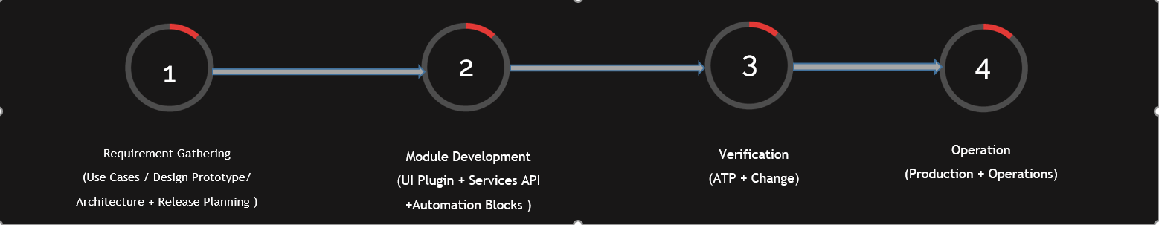

Scope of Work

SYNECTIKS will provide its custom solutioning and management services to the Customer. The SYNECTIKS custom solutioning services will be executed based upon information provided by the Customer, including detailed information of the solution to be developed and deployed.

Solution Services Outline

- Work with Customer to identify custom solution requirements.
- Draft a release plan and verification strategy in conjunction with Customer
- Develop the business modules and deploy in any cloud.
- Participate in acceptance testing and change management process.
- Assist the Customer with final deployment in production and operation management lifecycle.
- Review and Transition the completed project

Customer has provided the below Scope of Work to SYNECTIKS during initial conversations.

Manage the lifecycle of Netflix assigned jobs at task level with the tools and process that will support the following minimal requirements more efficiently.
- Automate the collection and processing of the Leverage report information into the Master Tracker format
- Automate the collection and processing of the Teamwork information into Master Tracker format
- Create front-end for manual information key-in of project data into Master Tracker format. Need driven by:
  - Timing gap in data availability from Leverage report (PMs sometimes have to launch project before report data is available which means they manually enter tracking data)
  - Project data not part of Leverage or Teamwork report required for tracking
- Ability to produce both automated and on-demand reporting
Note: The solution must be designed in a flexible and expandable manner, with the ability to add new categories of information and increase reporting granularity.

Solution Details

The purpose build workflow management solution provides fine-grained control over the task management, task assignment and business insights.

Functional Modules

The following functional modules need to be developed as depicted in the below table:

Name | Description
- Automated Leverage/TeamWork Data Collection | Automated jobs to periodically collect the leverage data and populate the database so that task management system can operate on that.
- Front end for manual information key-in of project data | Tracking and updating leverage data in database via some user interface so that Admin / PM can update the data with project information.
- Automated and On-demand reporting. | Export Master tracker data in specific format so that they can be feed into Plunet tool and bills get generated in Plunet.
- Transfer Master Tracker Information to plunet | Automated jobs to exported data and feed into the plunet tools via plunet API or directly ingest into plunet database.
- Automated Reconciliation | Automated jobs to verify that information is accurate and reconciled between Leverage report information, the Master Tracker and Plunet invoicing information
Common Modules (Minimal features for all apps)
- User and Role Based Access Control | Manage Admin / PM / Linguist authentication and authorization and deliver different access and views for different users.
- Preference & Setting Management | User specific preference management

Solution Stack

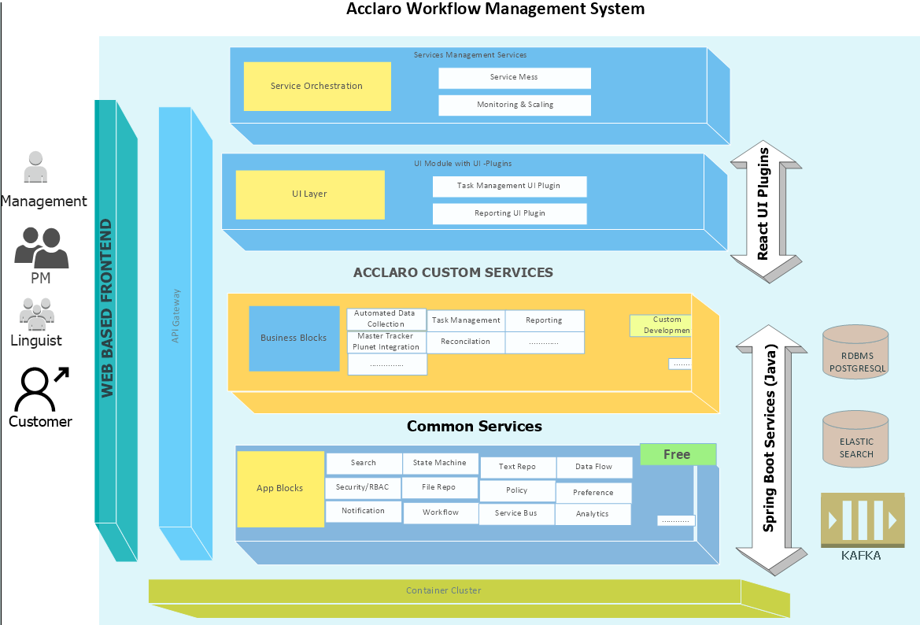

Note :
A fully microservices based application will be developed with the solution stacks as follows:
Backend Services API – Common and custom services API are developed in Spring Boot Based Java Services.
Front End Services -- Small ReactJs based UI plugins are built and hooked into a UI plugin framework from Synectiks.
Entire solution is deployed in Kubernetes cluster with Continuous deployment system.

Processes and Approaches
When recommending an Agile execution approach, Synectiks considers the following core activities and concepts to be the most critical to the success of project execution. While we are willing to be flexible on our execution approach, we believe that eliminating these activities reduces the effectiveness of the agile approach.
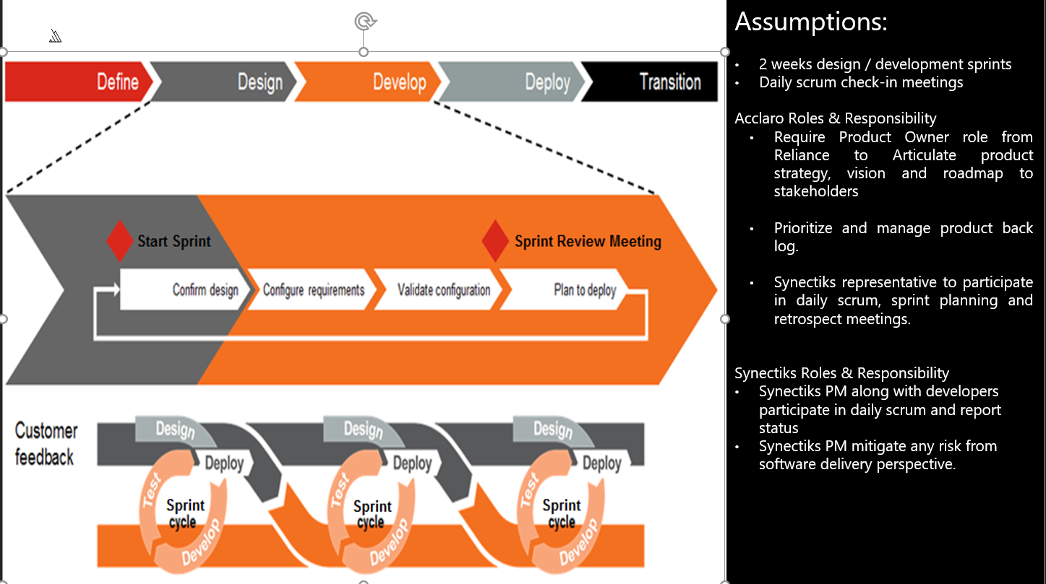
A typical Sprint Cycle as follows:
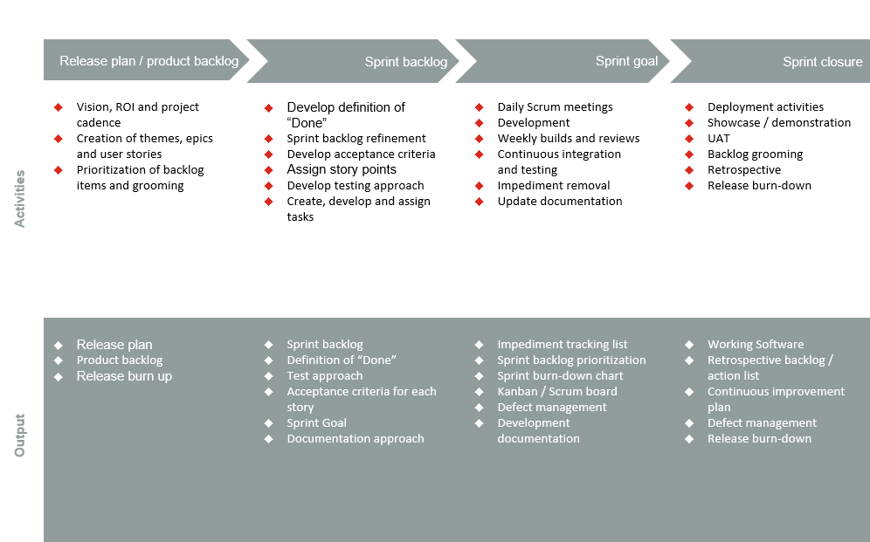

Project Management & Deliverables
A SYNECTIKS Project Manager will schedule, coordinate, and assist SYNECTIKS personnel assigned to the custom solution building Project. The Project Manager will communicate regularly with SYNECTIKS personnel and be the single point of contact with the Customer’s assigned personnel to manage the project.
Team Structure

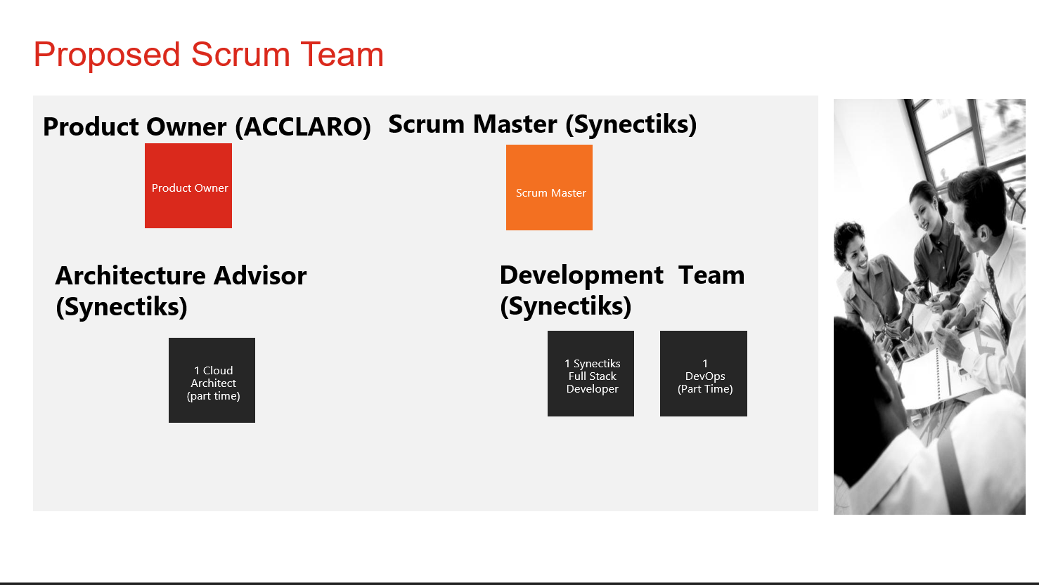

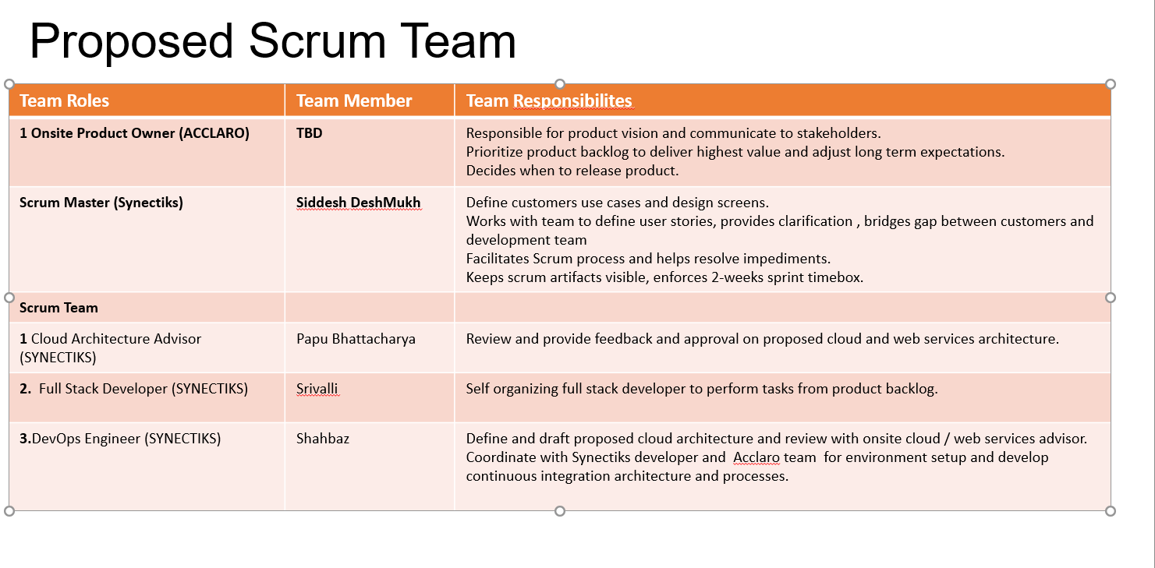

Phases & Deliverables

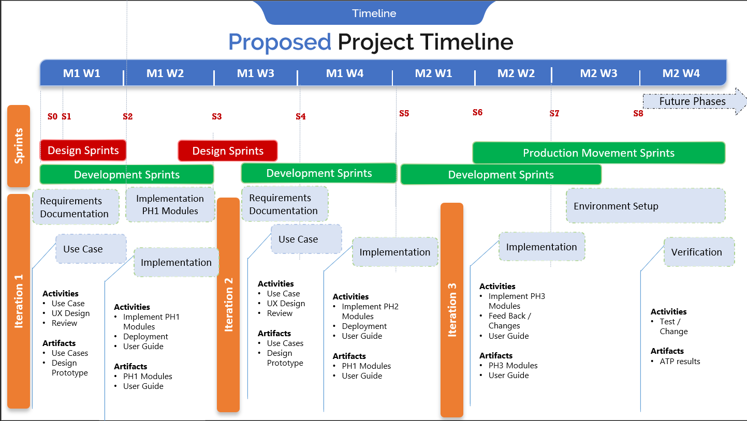

Estimated Costs
The Services under this SOW will be performed on a time and materials basis. SYNECTIKS initial estimate of effort and professional fees is identified in the following table. The LoE to perform is an estimate only, and is subject to change after SYNECTIKS receives the completed questionnaire sent to Customer along with this SOW.

Tasks & Estimates

A typical midsize module development effort is depicted below:

Role | Hourly Rate (USD) | Estimated LoE (Hours) | Sub-Total
Product Manager | $50 | 32 | $1,600.00
Architect | $110 | 16 | $1,760.00
UX Designer | $65 | 32 | $2,080.00
UI Developer | $60 | 40 | $2,400.00
DevOps | $70 | 96 | $6,720.00
Total |  |  | $14,560.00
NOTE: THIS IS AN ESTIMATE ONLY. THE ACTUALS WILL DEPEND UPON THE SIZE OF THE MODULE.

Module Wise Cost Estimates

Note – A midsized module cost around 14000$, assume that sizing index mean is 1. Any big sized module, the sizing index is >1 and small size module sizing index is <1. 0< SI < 2. We will give you detail function point estimates once the use cases and UX-design screen are clearly documented in requirement gathering phase.

Name | Description | Sizing Index | Unit Price | Total
Automated Leverage/ Teamwork Data Collection and store | Automated jobs to periodically collect the leverage data and populate the database so that task management system can operate on that. | 0.75 | $14,000.00 | $10,500.00
Front end for manual information key-in of project data  +  Automated and On-demand reporting +  Transfer Master Tracker Information to Plunet  +  Automated Reconciliation | Tracking and updating leverage data in database via some user interface so that Admin / PM can update the data. Also export monthly leverage data for Plunet tool so that bills get generated in Plunet. | 1 | $14,000.00 | $14,000.00
 |  |  |  | $24,500.00

Milestone Wise Schedule Estimates

Milestone | Estimated Time
Requirement Gathering | 15 Days
Phase1 – Modules Development | 1 Month
Production Deployment / Training / Transition | 15 Days
Total | 2 Months

NOTE:

The above Cost and Time Estimate is purely based on assumptions with a very HIGH-LEVEL view of the proposed functional module, it can very well vary from the estimated Schedule and Cost figures when we have detailed and fine grained requirement derived from the discovery phase.

Project Management

  - Coordinate Project Kickoff Meeting
    - Review requisite documentation required for the Cloud Security
    - Discuss objectives, and level of engagement required by various Customer business owners, IT staff and SYNECTIKS personnel
  - Create and maintain responsibility for the Project Plan/Schedule if needed
  - Coordination of all SYNECTIKS resources required to complete the Project
  - Provide Project status updates as needed
  - Schedule and conduct Project calls as needed
  - Schedule and conduct Project Closing call

Assumptions

SYNECTIKS fees, project schedule, and Deliverables are contingent upon the Customer’s and SYNECTIKS performance of their respective responsibilities and the assumptions set forth below. To the extent (i) Customer does not meet its obligations under the Agreement or this SOW, (ii) the applicable requirements and specifications change, or (iii) the assumptions listed below are not accurate, and as a result SYNECTIKS ability to perform its obligations in accordance with this SOW or the Agreement is adversely impacted, or additional Services are required to perform the revised scope, then the timelines and milestone dates shall be reasonably adjusted and any additional services required as a result of 7.1(i), (ii) or (iii) above shall be billed to, and paid for by Customer at SYNECTIKS standard rates on a time and materials basis. SYNECTIKS has made the following assumptions in preparing this SOW:

General

- Customer representatives shall be available as necessary to, among other things, attend meetings, provide feedback, approve deliverables, validate findings, and test Deliverables as appropriate.
- As work progresses, there may be changes and/or clarifications to the requirements that may impact deadlines and costs. Changes to the scope, schedule and cost of this SOW can be made at any time by agreement of the parties.
- It is assumed that the Services under this SOW shall proceed continuously and there shall be no work interruptions or stoppages ordered other than as may be contemplated by a project plan (if applicable).
Any delay to the start of Services under this SOW which is not under the control of SYNECTIKS, including, but not limited to, delays in approvals, procurement or staff availability, may require an adjustment of fees and expenses and/or the Project schedule for completion of the Services under this SOW.

Project Specific

- Customer shall provide SYNECTIKS access to all necessary workstations, servers, data and telecommunications facilities and equipment in a timely fashion. In addition, Customer shall timely provide [any consents, approvals, and authorizations necessary to allow SYNECTIKS to use products and services provided under Customer’s third-party contracts which are necessary to enable SYNECTIKS to perform the Services.] Instruction: This description of the Customer’s support activities should be more specific if there is more information on what specific agreements, licenses, etc. need to be signed.
- Tasks, meetings, and reviews that require the input of Customer personnel may impact delivery and costs of SYNECTIKS deliverables if not met within the scheduled timeframes.
- Unless otherwise specified above or in a project schedule agreed by the parties, SYNECTIKS consultants will work an average of forty (40) hours per week on the Project.

Responsibilities

The following outlines each party's responsibilities in making this SOW a success.

SYNECTIKS Responsibilities

SYNECTIKS shall provide an SYNECTIKS Contact Person in Paragraph 8 of this SOW who will serve as the primary point of contact with the Customer team and who will coordinate all activities of the SYNECTIKS engagement team. SYNECTIKS resources will provide a weekly status report to the Customer Project Manager using a reporting format defined in conjunction with Customer. SYNECTIKS will include in each status report issues that could result in schedule and cost changes, or issues that may be deferred to a subsequent SOW due to the actual level of Customer staffing, changes in functionality and other unplanned changes.

Customer Responsibilities

Customer shall name the Customer Project Manager in Paragraph 10 of this SOW. The Customer Project Manager shall serve as the primary point of contact with the SYNECTIKS engagement team and shall be the Customer’s decision-maker for this Project. In order to provide the Deliverables in accordance with the indicated timeframe, SYNECTIKS requires that the Customer Project Manager be available in a timely manner to participate in all necessary meetings and respond to information requests in a timely manner, specifically: information requests within one (1) business day, and reviews of documents for feedback or sign-off within two (2) business days. The Customer Project Manager shall also coordinate Customer participation during the Project and timely access to Customer resources and information.

In the event that the SYNECTIKS Contact Person or the Customer Project Manager changes, the parties shall amend this SOW to reflect the change.

Third-Party Software and Services

Customer acknowledges that certain functionality and performance of the Services and Deliverables may be dependent upon the availability and performance of third-party software and services. Customer agrees that such third-party software and services are subject to the terms and conditions of separate license(s) and services agreement(s) solely between Customer and such third-party provider and are outside the control of SYNECTIKS. SYNECTIKS specifically disclaims any warranty or liability with respect to such third-party software and services.

Change Order Process

All Material Changes made to this SOW shall be documented in a written Change Order. For purposes of this SOW, a Material Change shall mean any change arising as a result of: (i) incorrect or incomplete information or documentation provided to SYNECTIKS by Customer, (ii) delays caused by Customer, (iii) revisions to the business or technical requirements and/or design specification by either party that also increases the estimated scope, schedule and/or cost of the Project. The parties will informally discuss any proposed change and the party that would like to adopt the change shall submit its request to the other party in writing. SYNECTIKS will include in any proposed Change Order (or in its response to a Customer Change Order) its comments on the requested change including as to technical feasibility and any consequential changes to the scope, schedule, and/or cost of the Project. If the parties agree to the change, this shall be recorded in writing and signed by the parties as a Change Order. The parties shall not be bound by a change or variation until a Change Order has been fully executed. For the avoidance of doubt, such Change Order shall also be governed by the terms and conditions set out in the PSA. Customer acknowledges that a Change Order may result in additional cost to Customer and that such amount is outside of the fixed price quoted above.

Out of Scope

Third Party API SLA’s

The following activities are out of scope:

- Meet Business SLA for any third-party integration API
- Managed Services and System Deployment

Unless the entire system deployment model (Cloud / On-prem) and total architecture is defined, we have not made any assumption on operation cost like hardware’s & managed services.

Miscellaneous

Customer Project Manager:
Contact Person for this SOW:
e-mail:

Customer Accounts Payable Contact:
Customer Contact Person:
e-mail:

SYNECTIKS Contact:
SNECTIKS Contact: Jithendra B Kolluru
e-mail: jithendra.kolluru@synectiks.com

Order Date: The term “Order Date” for this Statement of Work shall mean the date this Statement of Work is signed by SYNECTIKS.

In the delivery of the service, SYNECTIKS makes the following assumptions:

- IM (skype for Business) will be provided with necessary Customer IT and Business contacts to report any necessary information during the Project
- Customer will respond in a timely manner to request for information. Any delays may cause delays in the agreed timeline
- Project will begin after the SOW is Signed, on a mutually agreeable date
- If there is a schedule delay not exclusively caused by SYNECTIKS, or a change of scope or deliverables, there may be a mutually agreed to price increase

The headings used in this Agreement are for convenience only and have no legal effect and shall not in any way define or limit the scope of this Agreement.

SOW Acceptance

As a duly authorized representative, I hereby acknowledge, accept, and authorize this Statement of Work.

Accepted & Agreed To:
ACCLARO Inc. | SYNECTIKS Inc.
Signature : | Signature :
Name: | Name: Jithendra B Kolluru
Title: | Title: Director - Cloud Services & Operations
Date: 9/18/2020 | Date: 9/18/2020

